|  |
| --- |
| **DATA ANALYSIS OF COVID-19**  **21CSS101J – PROGRAMMING FOR PROBLEM SOLVING**  **Mini Project Report**  *Submitted by*  **Joel Rufus.J [Reg. No.: RA2211026010231]**  **B.Tech. CSE - Al-ML**  **Deepesh.N [Reg. No.: RA2211026010254]**  **B.Tech. CSE - AI-ML**  **SRMIST-01.jpg**  **SCHOOL OF COMPUTING**  **COLLEGE OF ENGINEERING AND TECHNOLOGY**  **SRM INSTITUTE OF SCIENCE AND TECHNOLOGY**  **(Under Section 3 of UGC Act, 1956)**  S.R.M. NAGAR, KATTANKULATHUR – 603 203  KANCHEEPURAM DISTRICT **December 2022** |

**TABLE OF CONTENTS**

|  |  |  |
| --- | --- | --- |
| **Chapter No.** | **Title** | **Page No.** |
| 1 | Problem Statement | 3 |
| 2 | Methodology / Procedure | 4 |
| 3 | Coding in Python | 5 |
| 4 | Results | 6 - 12 |
| 5 | Conclusion | 13 |

**PROBLEM STATEMENT**

To analyze the given date set of COVID-19 using Python libraries :

* Numpy
* Matpoltlib
* Pandas
* Seaborn

**PROCEDURE/METHODOLOGY**

* Using Spyder Anaconda navigator

* The latest Covid-19 data is downloaded from <https://www.kaggle.com/> in the form of .csv format

.

* In the IDLE , the required python libraries are called which includes numpy , matplotlib , seaborn , Pandas .
* Using valid syntax the downloaded file is imported to the syntax of seaborn
* Using pandas command (pd.read) the file is uploaded
* By using sns.replot the graph is plotted
* Sns.catplot , sns.relplot , sns,barplot , sns.countplot
* Bar graph , line graphs , point graphs are plotted for the given data

**CODING IN PYTHON**

Importing python libraries:

**WE USE THE FOLOWING LIBRARIES TO ANALYSE THE GIVEN DATA**

import pandas as pd

import seaborn as sns

import matplotlib.pyplot as plt

import numpy as np

Reading and printing the inputted .csv file:

**THE DATA HAS BEEN IMPORTED INTO THE INTERPRETER**

data=pd.read_csv(r"C:\Users\rufus\Downloads\DATASETT\country_wise_latest.csv")

**THE DATA IS PRINTED AS OUTPUT :-**

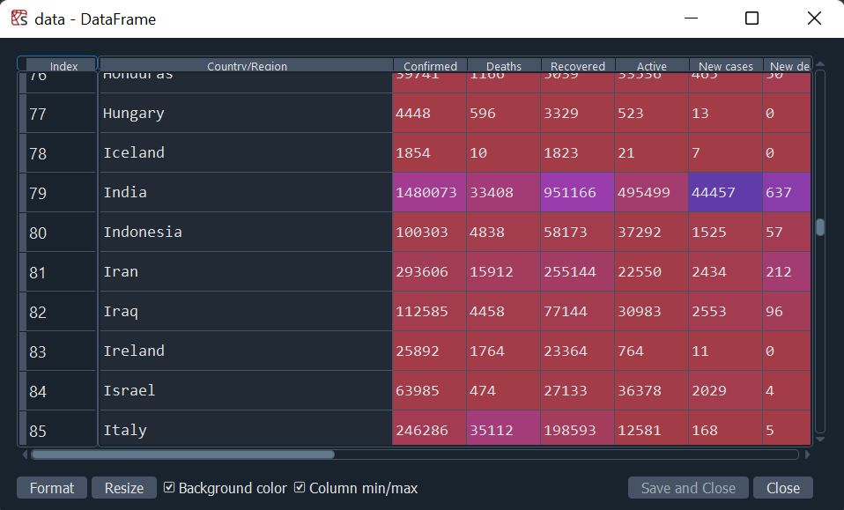

**Plotting using relplot:**

**WE FIND THE NUMBER OF DEATHS WITH RESPECT TO THE NO OF CONFIRMED CASES USING “replot”**

**CODE:-**

sns.relplot(x="Deaths" , y="Confirmed" , kind='line' , data=data)

OUTPUT:

THE GRAPH IS PRINTED AS OUTPUT:-

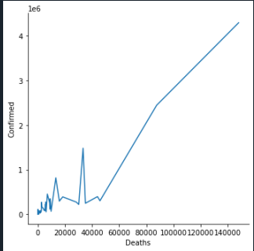

Discription :

The above Line Graph represents the Number of confimed cases and Death rate over the period of time

**Plotting using Catplot:**

sns.catplot(x="Country/Region" , y="Deaths" , data=data)

Output:

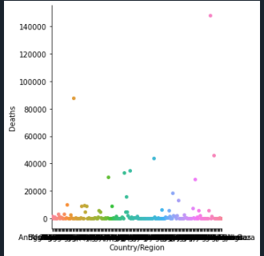

Graph Discription :

The Graph represents the scatter plot of number of deaths in Each county/region during the covid – 19 crisis

Analyzing Using Pairplot library :

data=pd.read_csv(r"C:\Users\rufus\Downloads\DATASETT\country_wise_latest.csv")

sns.pairplot(data)

Discription :

The pair plot gives the all the possible Graphs for the given data set which is represented below

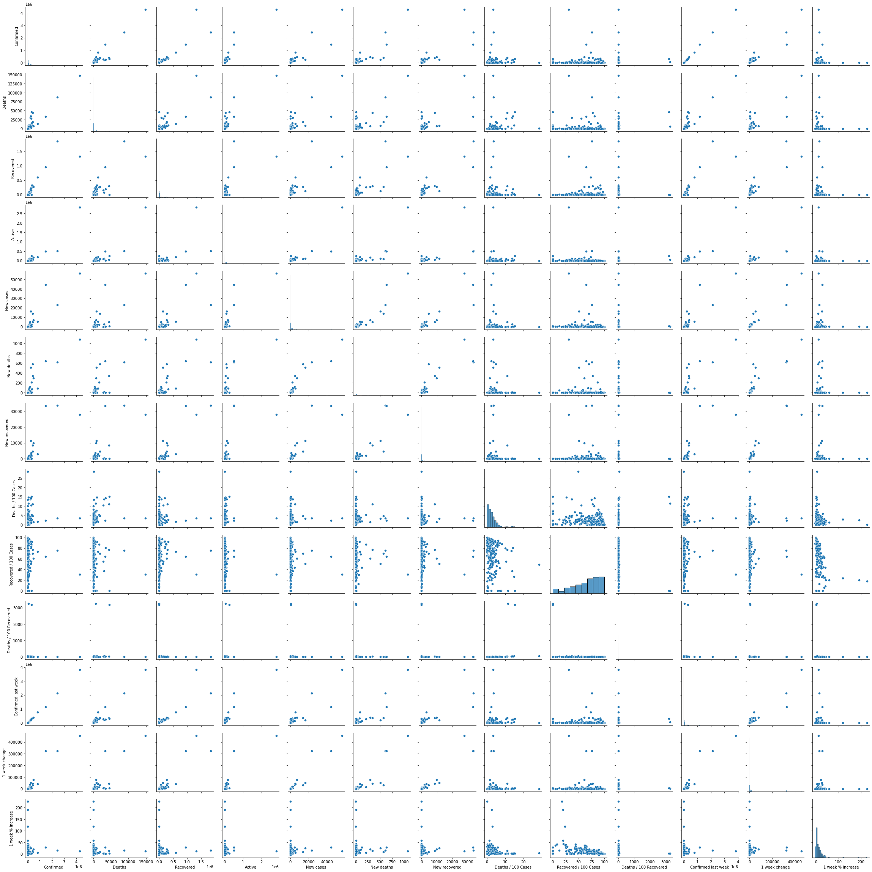

Plotting using Barplot library:

data=pd.read_csv(r"C:\Users\rufus\Downloads\DATASETT\country_wise_latest.csv")

data

sns.barplot(y="Deaths / 100 Cases" , x="Recovered / 100 Cases" , data=data)

Output:

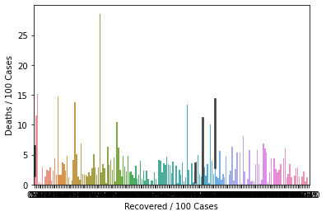

Discription : Bar graph of Deaths per 100 cases and recoverd per 100 cases in each country vise .

**Analyzing using countplot:**

data=pd.read_csv(r"C:\Users\rufus\Downloads\DATASETT\country_wise_latest.csv")

sns.countplot(data['New deaths'])

Output:

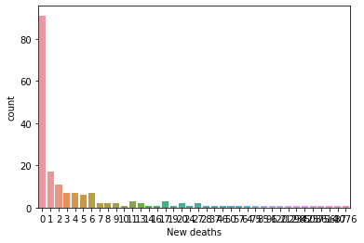

Discription :

Count plotted graph New deaths vs Count has been plotted above

CONCLUSION

Despite the simplicity of our results, we believe that they provide an interesting insight into the statistics of the COVID-19 outbreak in two of the worst affected countries . Our results appear to indicate that the Graphical representation may be more suitable in modelling the incidence of COVID-19 and other infectious diseases in both the growth and decay phases, and for short term predictions of the growth (or decay) of the number of new cases when no intervention measures have recently been implemented. In addition, the results could be useful in contributing to health policy decisions or government interventions—especially in the case of a significant second wave of COVID-19. However, these results should be used in conjunction with the results from other more complex mathematical and epidemiological models.